<https://stackoverflow.com/questions/13238219/sql-server-express-cannot-connect-error-28-server-doesnt-support-requested-p>

Open SQL Server Configuration Manager

Administration tools=>Computer Management

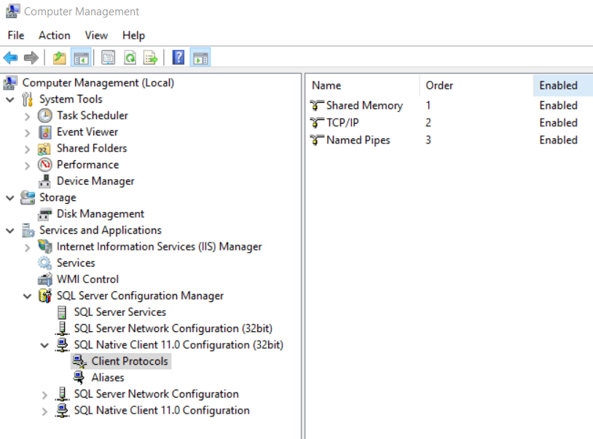

Set TCP/IP to enabled, Named Pipes to enabled.

Do this for all SQL Server Native clients

You need to do this on both remote and local machine.